# Setup Requirements and Options for PGSuper Version 2.3

PGSuper 2.3 Beta 2 has many significant changes from Version 2.2. WSDOT has added LRFR Load Rating capabilities and improved the system architecture to better support “plug in and extension” features needed to support customization of PGSuper (this is instrumental for development of the TxDOT Optional Design feature, as well as other future enhancements). This document details what you need to know to get started with PGSuper version 2.3.

# PGSuper Catalog Server

The format of the data stored on a PGSuper Catalog Server has changed (this is the ftp server where the Master Library file and the PGSuper Project Templates are stored). Library and template files are now stored in a compressed archive for faster downloads. The MakePGZ utility program can be used to package together the Master Library file and the PGSuper Project Templates as well as create the associated MD5 checksum file. The MakePGZ utility program can be found in the PGSuper installation folder.

Prepare your PGSuper Catalog Server by following these steps:

1. Don’t remove the PGSuperCatalog.ini file or associated library files, templates, and MD5 check sum files. PGSuper versions 2.2 and earlier still requires them.
2. Update your Master Library File to include at least one Load Rating Criteria entry. The default library entry contains settings consistent with the AASHTO Manual for Bridge Evaluation, 1st Edition, 2008. If the Master Library file does not contain a Load Rating Criteria entry, users will be prompted to create one when they open an existing file or create a new file.
3. Organize project template files. Project templates can now be in a folder tree that can be any level deep.
4. Optionally, you can add icon files to the project template folders. These specially named icons will be displayed in the New Project dialog.
   1. Icon file with same name as template file: icon will be displayed for that template only
   2. Icon file with same name as template folder: icon will be displayed for all templates in that folder and all lower lever folders, unless addition icon files are provided
   3. The default icon will be used in an icon file is not provided
5. After installing PGSuper, use the MakePGZ utility to build a PGSuper Library and Templates Package file and the associated MD5 checksum file. The command line is:  
   c:\program files\wsdot\pgsuper\makepgz *filename*.pgz *library*.lbr *templatefolder*  
   Where *filename* is the name of the PGZ file that will be created. An MD5 file with the same name (with MD5 extension appended) will also be created  
   *library* is the name of your Master Library File  
   *templatefolder* is the root of the folder structure that contains the PGT template files and optional icon files
6. Copy the resulting PGZ and MD5 files to the FTP server
7. Create a PGSuperPackages.ini file on the server. The format of the file is similar to the PGSuperCatalog.ini file. The format is shown in this example:  
   The name in the square brackets will be displayed to the user as a package name in the Program Settings dialog   
   Format specifies the format of the package, use “pgz” for a compressed package  
   WebLink is the URL for a web site associated with the package. Users can click on a link in the Program Settings dialog to display this web site. This parameter may be omitted.  
   Version_x.y.z_PgzFiles is the path to the PGZ file created by MakePGZ. This is the location of the files from Step 3 above. Replace x.y.z with the version of PGSuper that PGZ file is compatible with. The MD5 file must be in the same folder as the PGZ file.  
   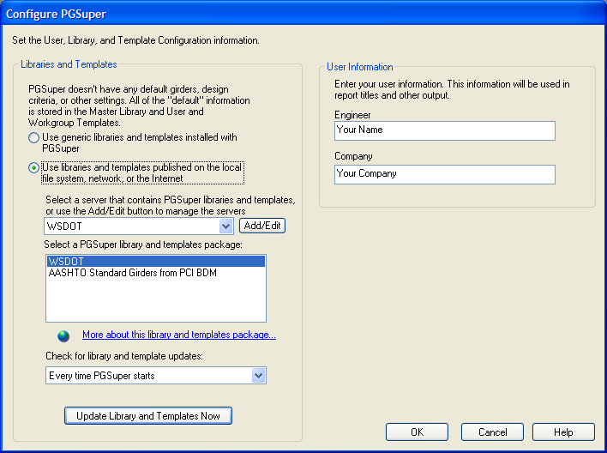

Name in square brackets   
[WSDOT]

WebLink

[WSDOT]

Format="pgz"

WebLink="http://www.wsdot.wa.gov/eesc/bridge/software/PGSuper/LibraryInfo.html"

Version_2.3.0_PgzFiles="ftp://ftp.wsdot.wa.gov/public/bridge/Software/PGSuper/Version_2.3.0/WSDOT.pgz"

# Library Editor Program

The library editor program, used for editing the Master Library File, has been eliminated. Master Library files can now be created and edited in PGSuper.

# New Projects

The New Project dialog has been redesigned to group documents by type and has better visual attributes.

The top level of the tree structure on the left of the dialog lists the different document types that can be created (you’ll soon see the TxDOT Optional Design document type listed here). This includes PGSuper Projects and Master Library Files. The tree below the PGSuper Projects node reflects the directory structure of the project templates. Clicking on a branch of the tree displays the available templates on the right side of the dialog. Note how the choice of icon shown in the dialog below gives the users a visual cue that voided slab sections are used in these templates.

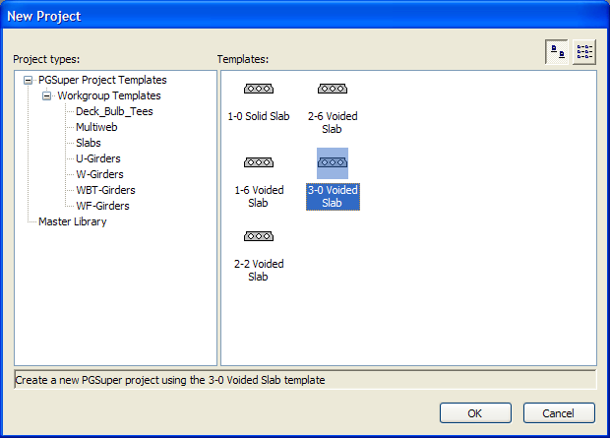

There is an icon file in the Slabs folder named slabs.ico. The icon image is applied to all templates in this folder